Task 1

1. git --version - To check the version of the git

Screen Shot 02-Oct-22 at 2.07 PM.png

2. git init - To intialize git

Screen Shot 02-Oct-22 at 2.07 PM - 2.png

3. git config --global user.name "Sakti-Sundar" - Setting the name of the User

Screen Shot 02-Oct-22 at 2.07 PM - 3.png

4. git config --global user.name - Checking the updated user name

Screen Shot 02-Oct-22 at 2.08 PM.png

5. git config --global user.email "saktisundar31@gmail.com" - Setting the registered email id in github

Screen Shot 02-Oct-22 at 2.08 PM - 2.png

6. git config --global user.email - Checking the updated email id

Screen Shot 02-Oct-22 at 2.08 PM - 3.png

7. git add README.md - Adding the created README.md file to github

Screen Shot 02-Oct-22 at 2.09 PM.png

8. git status - Checking the status of the files

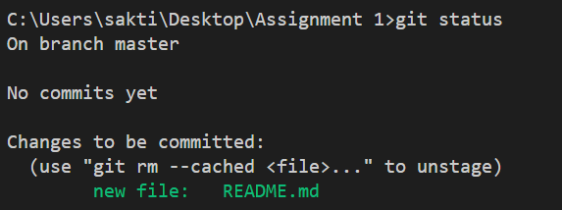

9. git add . - adding all the updated files

Screen Shot 02-Oct-22 at 2.09 PM - 3.png

10. git commit -m "first commit" - commiting the files to git

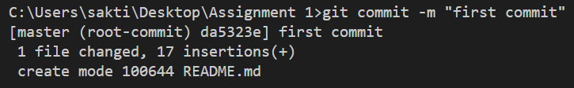

11. git branch - checking the branch in which the files are getting pushed

Screen Shot 02-Oct-22 at 2.10 PM - 2.png

12. git branch -M main - Changing the branch to main

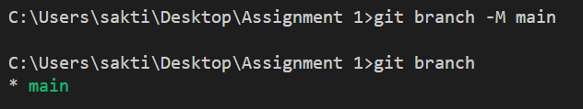

13. git remote add origin https://github.com/Sakti-Sundar/assaignment-1.git - Setting the repositry in which the files should be pushed

Screen Shot 02-Oct-22 at 2.11 PM.png

14. git remote -v - checking it

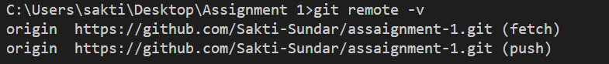

15. git push origin main - pushing the files to the origin

